СОДЕРЖАНИЕ

 | Введение | 4
1 | Understanding Lectures | 5
2 | Corporate structure | 8
3 | Scientific Library | 11
4 | International Conference | 12
5 | Poster Presentations | 14
6 | Writing a Summary of an Article | 17
7 | Crediting Sources | 20
8 | Project presentation | 24
9 | Language for Presentations | 26
10 | Describing percentages | 28
11 | Narrative writing | 31
12 | Clarifying a sequence | 33
13 | How to organize ideas logically/chronologically | 36
14 | Writing in 3rd person in APA style (Neutral Style) | 39
15 | How to write an abstract | 41
16 | Writing a Research Plan | 44
17 | How to write business letters | 47
18 | Linking, organizing ideas | 51
19 | Complex Subject | 54
20 | Complex Object | 56
21 | Passive Voice | 58
22 | Sequence of tenses | 63
23 | Infinitive and Infinitive clause | 66
 | Список литературы | 68

ВВЕДЕНИЕ

Данные методические указания разработаны на кафедре «Иностранные языки» на базе Государственного общеобязательного стандарта образования (ГОСО РК), типовой рабочей модульной программы по специальности, а также рабочей модульной учебной программы и силлабуса, составленных на кафедре иностранных языков ВКГТУ им. Д. Серикбаева. Методические указания предназначены для магистрантов, обучающихся по специальностям: 6M050600 Экономика, 6M050700 Менеджмент, 6M050800 Бухгалтерия и аудит, 6M051100 Маркетинг. Методические указания можно использовать для СРМП и СРМ.
Методические указания ставят целью совершенствование навыков письма (статей, резюме, стендовых докладов, деловой переписки и т.п.), чтения литературы по специальности, развитие коммуникативных навыков говорения с использованием профессиональной лексики (доклады, презентации, отчеты и др.), а также навыков перевода текстов по специальности.
Методические указания состоят из 23 разделов. Каждый раздел включает 1 текст и коммуникативные упражнения на отработку соответствующих навыков.
Объем и тематика материала, типология заданий соответствуют типовой учебной программе по специальности по дисциплине «Иностранный язык (профессиональный)».

1 UNDERSTANDING LECTURES
Lectures are an essential aspect of student life. They serve as one of the main ways to deliver content knowledge to students. Understanding a lecture is not simply a matter of attending the lecture and listening. You need to prepare for the lecture by doing some pre-lecture activities; you need to be active during the lecture by listening for the main points and making notes; and you need to do follow-up work after the lecture has finished to strengthen your understanding. Each of these stages is described in more detail below, followed by a summary of the whole process
Pre-lecture | - Read about topic in order to get a general understanding.  - Think of questions you want the lecturer to answer.  - Study topic-specific vocabulary.
 | ↓
During the lecture | - Listen for main ideas of the lecture. Listen carefully for lecture cues which will help you follow the structure. Avoid noting digressions.  - Make notes of the main points. Use abbreviations and symbols to save time. Make sure your notes have a clear structure.  - Also note down any questions you have which occur to you during the lecture.
 | ↓
Post-lecture | - Compare notes with other students to add missing information.  - Check your notes and improve clarity, e.g. by writing full words for some abbreviations.  - Try to find answers to any questions you had during the lecture.

Note-taking
Almost any word can be shortened during note-taking. Below are some ideas about how to do this.

Use the beginnings of words: pol – politics; gov – government; subj – subject; info – information; intro - introduction

Use the beginnings of words with the final letter: govt/gov't – government; interl/inter'l – international;
- Omit vowels: prblm – problem; schl – school; bkgd - background
- Abbreviate –ing: ckg – checking; ckng – checking; ck'g - checking
- Abbreviate specific words from the lecture: AR - acid rain; S – sulphur; N – nitrogen; pol – pollution; facs - factories

Common symbols & abbreviations
There are many common abbreviations and symbols which you can use for note-taking. You probably already know many of these (especially the mathematical symbols), but perhaps had not thought about using them before. Try to learn some of these and start using them when you take notes.

Symbols |  | Abbreviations
Symbol | Meaning | Abbrev | Meaning
→ | leads to, causes (result) | e.g. | for example
← | caused by, because of (reason) | et al | and others
↑ | increase, more, go up, up | i.e. | that is
↓ | decrease, less, go down, down | etc. | etcetera, and so on
= | equal to, is, are | C | century, C20: 20th century
≠ | not equal to, is not, are not, is the opposite of | diff | difference, different, difficult, difficulty
≈ | approximately | approx | approximate(ly) (see also ≈)
> | greater than | imp | important, importance
>> | much greater than | max | maximum
< | less than | min | minimum
∴ | therefore | 1st | first (similarly 2nd, 3rd, 4th)
∵ | because | UK | United Kingdom
″ ″ | ditto (same as above) | Q | question
& + | and | A | answer
# | number | no. | number (see also # symbol)
$ | money | poss | possible, possibly
@ | at | prob | problem, probable, probably
′ | minutes/feet | sf | compare with
″ | seconds/inches | v | very
♂ | man, men, male | w/ | with
♀ | woman, women, female | w/o | without

Task 1. Rewrite the notes below as complete sentences using the list of abbreviations above.

1. 25% road accidents ← drunk drivers in 1998.
2. 50% British - holidays abroad in 1999: cf. 1991 – 42%. Most pop. destinations – Med. e.g. Greece, Turkey, Spain
3. Mrs Pankhurst et al - reponsible for votes for
4. The temp. ↓ to < 4 º overnight. 5. Truancy: ↑ cf ↓ in 1999.

Task 2. Try to rewrite the following sentences in note form.

1. Heat causes ice to melt.
2. Turn to pages 5 and 7 and note well the example which compares male and female school leaving ages, career prospects, etc.
3. The cost of foreign travel has fallen as a result of the strong pound.
4. Poverty is both a cause and effect of environmental degradation.
5. The child mortality rate was high in the early Nineteenth Century.
6. This was largely due to insanitary conditions which caused diseases, especially cholera.
7. The population of London is greater than some countries.
8. In the same passage, note the cost of travelling by bus compared with the tube .
9. In the nineteen eighties less than ten percent of graduates were employed within a year of graduating.
10. Today, graduate employment is rising, especially in the information technology sector.

2 CORPORATE STRUCTURE

Corporate structure refers to the organization of different departments or business units within a company. Depending on a company’s goals and the industry which it operates in, corporate structure can differ significantly between companies. Each of the departments usually performs a specialized function while constantly collaborating with each other to achieve the corporate goals and values.
Departments in a company include Human Resource, IT, Accounting and Finance, Marketing, Research and Development (R&D), and Production. Some product-based or project-based companies may divide up business units by addressing a single product or project as a department.

Types of Organizational Structure

There are four general types of organizational structure that are widely used by businesses all around the world:

Functional Structure

Under this structure, employees are grouped into the same departments based on similarity in their skill sets, tasks, and accountabilities. This allows effective communications between people within a department and thus leads to an efficient decision-making process. Companies with departments such as IT and Accounting are good examples of a functional structure.

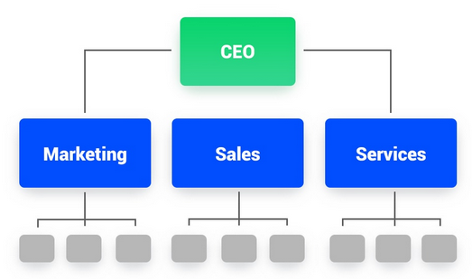

2. Divisional Structure

This structure organizes business activities into specific market, product, service, or customer groups. The purpose of the divisional structure is to create work teams that can produce similar products matching the needs of individual groups. A common example of the divisional structure is geographical structure, where regional divisions are built to provide products or service to specific locations.
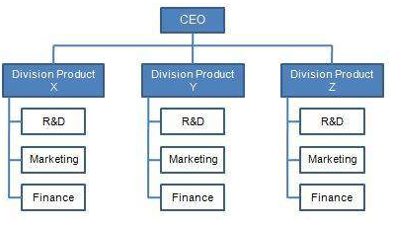

3. Matrix Structure

Matrix Structure is a combination of functional and divisional structures. This structure allows decentralized decision making, greater autonomy, more inter-departmental interactions, and thus greater productivity and innovation. Despite all the advantages, this structure incurs higher costs and may lead to conflicts between the vertical functions and horizontal product lines.

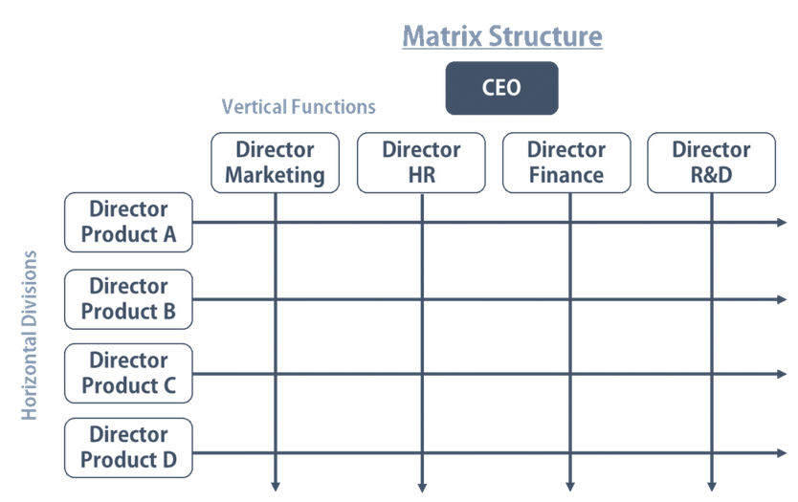

4. Hybrid Structure

Like the Matrix Structure, the Hybrid Structure combines both functional and divisional structure. Instead of grid organization, Hybrid Structure divides its activities into departments that can be either functional or divisional. This structure allows utilization of resources and knowledge in each function, while maintaining product specialization in different divisions. Hybrid Structure is widely adopted by many large organizations.
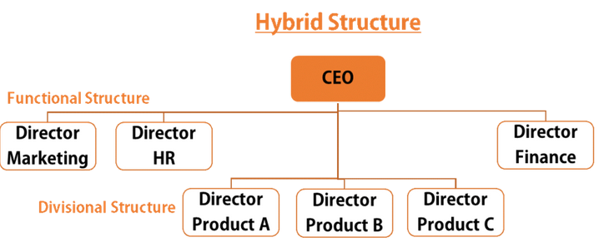

Learning About a Company’s Corporate Structure

When an FP&A analyst performs various analyses and financial modeling, corporate structure is often one of the first things taken into consideration, because how the departments are defined directly influences the construction of any model.

3 SCIENTIFIC LIBRARY


Central Scientific Library of Ministry of Education and Science of the Republic of Kazakhstan (Kazakhstan)

The Central Scientific Library of Ministry of Education and Science of the Republic of Kazakhstan (CSL-Kz) is a prominent stockholder of the scientific literature in Kazakhstan carrying out the functions of the natural scientific depositary (5, 3 millions of copies). The library stock presents the richest collections of the national and foreign publications, dissertations, scientific works, and private libraries of the Kazakh scientists. The specific composition of the materials is enormous: from the originals of manuscripts to the modern e-library.
CSL-KZ is information centre of the Ministry of Education and Science providing full information on development of the Kazakh research institutions including statistic data and information on realized and ongoing international projects as well as updating the information database on all scientific research institutions of Kazakhstan. The library issues the current and retrospective indexes in many branches of sciences for providing the fundamental and applied researches of the Kazakhstan science by the regional, problem-subject, retrospective bibliographical information.
At present CSL-KZ is in the forefront of the scientific-bibliographical branch of the Republic. It has a composite DB “Nature and Natural Resources of Kazakhstan”. CSL MES RK is an initiator and executor of the scientific-research projects in the sphere of library management and new information technologies. CSL is a participant of National programs on fundamental and applied research.
CSL-Kz coordinates network of scientific-research libraries of Kazakhstan. CSL-Kz is the centre of scientific propagation of Kazakhstan, the state politics and strengthening of the international relations. CSL-Kz is the member of national and international associations.

Task 1. Make a list of activities the library carries out.

Task 2. Name the main partners of the library.


4 INTERNATIONAL CONFERENCE
The 9th international conference on Management, Economics and Humanities, July 26–28, 2019 in London, UK aims to bring together academia, researchers and scholars to exchange information and share experiences and research results about all aspects of specialized and interdisciplinary fields. This event provides an opportunity for all to network, share ideas and present their research to a worldwide community. Discussion on the latest innovations, trends and practical concerns and challenges faced in these fields are also encouraged.

Important Dates:

08 July 2019 Paper Submission

12 June 2019 Early Registration

17 July 2019 Late Registration

Participation Opportunities

Oral presentation. Be an oral presenter of the conference and present your research to a truly international audience. Presentation slots are limited, so early submission is strongly encouraged. Send your abstract today.

Poster presentation. Send your research paper to be a poster presenter at the conference and show your research work to the audience throughout the conference days. A good opportunity for extended discussions.

Virtual presentation. If you can’t attend the conference in person but want to share your research with our international community, join as a virtual presenter

Publication. All accepted research papers will be published and indexed in the conference proceedings. All accepted abstracts will be published in the conference abstract book with ISBN.

Networking. Attending in ICMEH conference will provide an opportunity to network and share thoughts on recent advances with other academics and experts in the same or similar fields.

City Tour. Organizing Committee will offer to all participants a city tour free of charge, so learn about London’s vibrant past and present, with a friendly local guide.
The conference is seeking submissions related to the following conference topics: Management, Economics and Humanities. Other related topics will also be considered.
Submitted abstracts will be evaluated by the Scientific Committee. If abstract is accepted, author agrees to send full text paper, including results, tables, figures and references. All submissions should report original and previously unpublished research results no matter the type of research paper you are presenting. Manuscripts should meet the format set by the Conference committee and are subject to review.
Task 1. Fill in the registration form.
The 9th international conference on Management, Economics and Humanities, July 26–28
Call for Proposals and Participant Application
First Name: | Last Name: | Address (City):
Country of citizenship: | Telephone (WhatsApp): | Email address:
Job Title: | Institution: | Experience:

1) Type and Title of Contribution:
Oral Presentation Poster Presentation Virtual Presentation
Networking Publication
Title of Proposal (not more than 10 words):
__________________________________________________________________
2) Information for Conference Program (not more than 50 words)
___________________________________________________________________
___________________________________________________________________
3) Topic area: (Tick ✓)
- Information System Management
- Organizational Behavior and Human Resource Management
- Information Technology Management
- Development Economics
- Economic Planning
- Counseling Psychology
4) Equipment Needed for Conference Contribution:
Please check the boxes of any equipment you will need for your workshop, presentation, or poster.
Projector CD Player/Speakers Laptop Computer
Whiteboard Flipchart Other: ____________
5) Abstract (maximum 250 words):
___________________________________________________________________
____________________________________________________________________________________________________________________________________________________________________________________________________________
6) Tick
This is the first time I attend ICMEH Conference
I am a First-time Presenter
7) Information for sponsoring your participation at ICMEH Conference.
Tick the relevant to you:
- I apply for sponsorship
- I attend the conference at my own expenses

5 POSTER PRESENTATIONS

Introduction
Posters are often used to share information and are an important part of many conferences, seminars and exhibitions. They may be used to present quite complex material, and so it is important that the information on them is well laid out, legible and attractively presented.

General points about posters
Poster presenters are usually offered a large area to display their material (typically 1m² or 2m by 1m).
Posters are usually read at a viewing distance of more than one metre. You will need to make sure that your poster is legible and easy to scan at this distance so that your information is understood quickly.
When making posters it is essential that you give careful consideration to their visual appearance as well as their content.

Methods of making posters
There are two popular approaches to making a poster, a one-piece method and a panel method.

Approach One - One-piece method
The presenter chooses to design the poster in one large piece (Figure 1). The design is prepared using a versatile software application such as Microsoft Powerpoint. It is designed and produced in A3 or A4 size and is then enlarged at the printout stage.
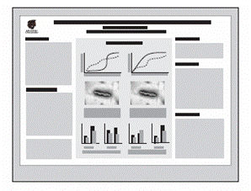
Figure 1:One-piece method

Approach Two - Panel method
The allocated poster area is divided up into a number of separate panels (Figure 2). These may consist of different elements such as text, pictures, tables or titles.
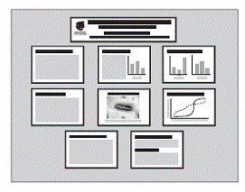
Figure 2: Panel method

Choose the production method that is most appropriate to your needs, abilities and resources.

Stages in producing a poster

Step One - Choosing content
The first step is to clarify the task that you have been set and the type of information that you will need to include on your poster. The following questions are useful reminders of the range of factors that you might need to consider before you start writing the text of your poster.
- What is the purpose of your poster - to report findings, present an argument, convince an audience or promote a product?
- Who will be looking at your poster - a specialist audience, the general public, other students?
- What will your audience be looking for - detailed information or a brief summary?
- Where will your poster be displayed - in a busy conference hall or in your department?
The answers to these questions will influence the nature and amount of material that you display.

Step Two - Making a plan
Once you have decided on the content of your poster, you need to consider the way the information should be displayed. A useful starting point is to prepare an outline plan that will help you make the most effective use of the space available to you. Your overall structure should be clear and logical so that the viewer’s eye naturally follows the flow of information in your display.

Step Three - Preparing your final poster
The following rules will help you produce an effective poster.

Using text
Once you have written your text, you need to choose how to present it. There are five main variables to consider.
- Font - choose a font that is easy to read at a distance. Two is often ideal; one for the headings and one for the main text.
- Type size - remember that your poster will be read by someone standing at about a metre away so the text will need to be legible at a distance. Use large type sizes; 24 point and 36 point can be clearly read at a distance.
- Line spacing or ‘leading’ - using one and a half or double spacing between lines of text greatly increases the legibility of your poster design.
- Alignment - most word-processing packages give you the option of aligning your text in different ways on the page; the main choices are left, right, centre and justified. Left aligned is the easiest to read, particularly when using large type.
- Case - text in UPPER CASE can be very difficult to read, even at close distances, and is best avoided.

Colour palette
Choose colours that work well together so that they don’t detract from the information in your display.

Diagrams
Displaying information on a poster gives you an opportunity to represent your data in an interesting and eye-catching way. Think about how your display can be enhanced through the use of illustrations, tables, charts or photographs.

Step Four - Showing your poster
Poster presentations can take many forms. Sometimes you will be asked to stand next to your poster, talking to people as they browse and answering questions about your work. At other times, your poster will simply need to ‘stand alone’ as part of a general display. It might be useful to think about how you can help an interested reader take information away from your poster: printing off A4 copies of one-piece posters or producing bullet-point summaries of panel posters are very effective ways of sharing your information.

Summary
Posters are a highly visual medium and can be a very effective way of communicating information to a wide audience. The challenge is to produce a poster design that is both pleasing to the eye and logical to the mind.

Task 1. Visit https://www.posterpresentations.com/free-poster-templates.html to select a template for your poster, and make a poster to present your research

6 HOW TO WRITE A SUMMARY OF AN ARTICLE

When Should You Summarize an Article?
There are a few instances when you might want to summarize an article. These are:
- To show how an author’s ideas support your argument
- To argue against the author's ideas
- To condense a lot of information into a small space
- To increase your understanding of an article
What Needs to Be Included in a Summary of an Article?
A great summary should include certain important elements that make the reading experience easier on the reader. A good summary will consist of the following elements.
- The main idea of the article is conveyed clearly and concisely
- The summary is written in the unique style of the writer
- The summary is much shorter than the original document
- The summary explains all of the important notions and arguments
- The summary condenses a lot of information into a small space
How Do You Summarize an Article?
Summarizing an article can be boiled down to three simple steps.
- Identify the main idea or topic.
- Identify the important arguments.
- Write your summary.
When trying to identify the central idea, you should ask yourself, “Why was this essay written and published?”
Example: In the article “Why Two Best Friends Doesn't Work,” author Cassandra Grimes argues that most teenage girls can't get along in groups of more than two.
To identify the important arguments you should read the article again. This time, read more carefully. Look specifically for the supporting arguments.
When writing your summary, make sure your first sentence summarizes the article. The rest of your summary should cover some of the central concepts used to support the thesis. Restate these ideas in your own words, and make your summary as short and concise as possible. Condense sentences and leave out unimportant details and examples. Stick to the important points.

How to Quote the Author of an Article
In “Cats Don’t Dance,” John Wood explains that in spite of the fact that cats are popular pets who seem to like us, felines are not really good at any activities that require cooperation with someone else, whether that is dancing or sharing.
If you are discussing the ideas of the author, you always need to make it clear that you are reciting their ideas, not your own.
How to Introduce the Ideas of the Author in an Article Summary
Use author tags
Use mentions of “the article” or “the text”
Add the page number that the information is found on in parenthesis at the end of the sentence.
Using Author Tags
In writing your summary, you need to clearly state the name of the author and the name of the article, essay, book, or other source.

List of Author Tags

Says |  | Explains | Comments
Persuades | Suggests |  | Understands
Argues | Reminds |  | Helps us understand
Elucidates | Presents |  | Intimates
Concludes | Presents the idea |  | Creates the impression
Criticizes | Defines |  | Highlights
Concedes | Shows |  | States
Thinks | Admits |  | Lists
Notes | Analyzes |  | Disagrees
Observes | Points out |  | Emphasizes
Discusses | Identifies |  | Implies
Insists | Responds |  | Shows
Proves | Rejects |  | Suggests

Adverbs to Use With Author Tags

Conclusively | Expressively | Realistically
Tightly | Angrily | Radically
Clearly | Dutifuly | Evenly
Occasionally | Quickly | Ironically
Honestly | Eagerly | Elegantly
Sharply | Rarely | Loosely
Exactly | Happily | Hastily
Perfectly | Sternly | Unexpectedly
Sometimes | Never | Justly
Devotedly | Finally | Warily
Wearily | Completely | Fully
Doggedly | Iconically | Sarcastically
Seriously | Carefully | Politely

Example Summary Paragraph

The following paragraph is an example of a one-paragraph summary of an article.

In “My Favorite Shoe,” Treyvon Jones explains that Nike shoes are the best brand of running shoe for serious track athletes. Jones supports this view by pointing out that Nike shoes are more comfortable, last longer, and provide more cushioning for the feet. He notes that the statistics from sales and scientific evidence of how Nike shoes are better for the feet support his claim. In addition, Jones points out that most professional runners use Nike and he tells his own story of how he won the 100-meter men's competition after switching to Nike shoes.

Below is a template showing the components of a great summary.

Summary Template

Part of Summary | Contents
Introduction Sentence | In “My Favorite Shoe,” Treyvon Jones explains (insert main idea).
Supporting Arguments | Jones supports this view by pointing out (insert author’s supporting arguments).
Final Point | In addition, (insert author’s overarching argument and point).

How to Edit and Revise Your Summary

Before you are officially done, it is important to edit your work. The steps below explain the process of editing and revision.
- Re-read the summary and edit out any obvious mistakes.
- Read your summary aloud. If anything sounds off, fix it.
- Let one of your peers read your summary. Make changes according to their feedback.
With that, your summary should be complete.

Task 1. Using the notes above write a summary of a scientific article in your field of study.

7 CREDITING SOURCES

Why citing is important
It's important to cite sources you used in your research for several reasons:
- To show your reader you've done proper research by listing sources you used to get your information
- To be a responsible scholar by giving credit to other researchers and acknowledging their ideas
- To avoid plagiarism by quoting words and ideas used by other authors
- To allow your reader to track down the sources you used by citing them accurately in your paper by way of footnotes, a bibliography or reference list

About citations
Citing a source means that you show, within the body of your text, that you took words, ideas, figures, images, etc. from another place.
Citations are a short way to uniquely identify a published work (e.g. book, article, chapter, web site). They are found in bibliographies and reference lists and are also collected in article and book databases.
Citations consist of standard elements, and contain all the information necessary to identify and track down publications, including:
- author name(s)
- titles of books, articles, and journals
- date of publication
- page numbers
- volume and issue numbers (for articles)
Citations may look different, depending on what is being cited and which style was used to create them. Choose an appropriate style guide for your needs.
Here is an example of an article citation using four different citation styles. Notice the common elements as mentioned above:
Author - R. Langer
Article Title - New Methods of Drug Delivery
Source Title - Science
Volume and issue - Vol 249, issue 4976
Publication Date - 1990
Page numbers - 1527-1533

American Chemical Society (ACS) style:
Langer, R. New Methods of Drug Delivery. Science 1990, 249, 1527-1533.
IEEE Style:
R. Langer, "New Methods of Drug Delivery," Science, vol. 249, pp. 1527-1533, SEP 28, 1990.
American Psychological Association (APA) style:
Langer, R. (1990). New methods of drug delivery. Science, 249(4976), 1527-1533.

What to cite
You must cite:
- Facts, figures, ideas, or other information that is not common knowledge
- Ideas, words, theories, or exact language that another person used in other publications
- Publications that must be cited include: books, book chapters, articles, web pages, theses, etc.
- Another person's exact words should be quoted and cited to show proper credit

Avoiding plagiarism
Plagiarism occurs when you borrow another's words (or ideas) and do not acknowledge that you have done so. In this culture, we consider our words and ideas intellectual property; like a car or any other possession, we believe our words belong to us and cannot be used without our permission.
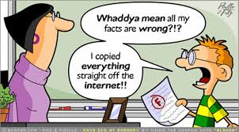
Plagiarism is a very serious offense. If it is found that you have plagiarized -- deliberately or inadvertently -- you may face serious consequences. In some instances, plagiarism has meant that students have had to leave the institutions where they were studying.
The best way to avoid plagiarism is to cite your sources - both within the body of your paper and in a bibliography of sources you used at the end of your paper.

Referencing a Book

e.g. Author. (Date). Title. Place of Publication: Publisher.

Task 1. Identify the parts of a book reference

Match the items on the right to the items on the left.

- Martin, R. C. | - Publisher
- (2009). | - Author(s).
- Clean code: A handbook of agile software craftsmanship. | - (Date).
- Upper Saddle River, NJ: | - Title.
- Prentice Hall. | - Place of Publication:

Task 2. Put the parts of a book reference in order.

- Prentice Hall. Clean code: A handbook of agile software craftsmanship. (2009). Martin, R. C. Upper Saddle River, NJ:
- (2012). McGraw-Hill. Morrison, T. New York, NY: Kiss, bow, or shake hands, sales and marketing: The essential cultural guide – from presentations and promotions to communicating and closing.

Referencing an Article

e.g. Author. (Date). Article title. Periodical Title. Volume(Issue), Page range. DOI or URL

Task 3. Identify the parts of an article reference

Match the items on the right to the items on the left.

- Van Note Chism, N., & Weerakoon, S. | - (Date).
- APA, meet Google: Graduate students' approaches to learning citation style. | - Periodical Title.
- 12 | - DOI or URL
- Retrieved from http://josotl.indiana.edu/ | - Page range.
- (2), | - Volume
- Journal of the Scholarship of Teaching and Learning, | - Article Title.
- (2012). | - Author(s).
- 27-38. | - (Issue),

Task 4. Put the parts of an article reference in order.

- 9-12. Ahmed, N.H., Edwards-Johnson, A., Antell, K., & Strothmann, M. doi:10.5860/rusq.53n1.9 53 Reference & User Services Quarterly, (1), (2013). Should librarians friend their patrons?
- doi:10.1139/z11-023 Canadian Journal of Zoology, Habitat loss, climate change, and emerging conservation challenges in Canada. 89 (2011). Coristine, L. E., & Kerr, J. T. (5), 435-451.

Referencing a Website

e.g. Xerox. (2016). Enterprise content management. Retrieved from https://www.xerox.ca/en-ca/services/enterprise-content-management-solutions

Task 5. Put the parts of a website reference in order.

- Retrieved from http://www.simcoemuskokahealth.org/Topics/HealthyEating/
- FoodSecurity/CostofHealthyEating.aspx .
- Cost of healthy eating.
- Simcoe Muskoka District Health Unit.
- (2014).

Task 6. Identify the parts of a website reference

Match the items on the right to the items on the left.

- Canadian Security Intelligence Service. | - Author/Creator.
- (2014). | - Title.
- Cybersecurity and critical infrastructure protection. | - Website
- Retrieved from https://www.csis-scrs.gc.ca/prrts/nfrmtn/index-eng.asp | - (Date).

8 PROJECT PRESENTATIONS

1. Plan your presentations.

Effective presentations have good structure. The structure will help you with recall and more importantly, will help your audience follow your presentation. Here’s a simple but effective structure:
- Introduction. Present the big idea. What is the major challenge or opportunity you want to see your audience to think about?
- Body. Give your audience three practical action steps to achieve the big idea.
- Conclusion. Restate the big idea and summarize the action steps.

2. Arrive early.

It is a good practice to arrive early and check out the equipment to make sure that things such as your microphone, PowerPoint, remote, and projector are working properly.

3. Keep the focus on you (not your slides).

Many presenters make the mistake of putting too much text on their slides. The audience spends more time reading the slides than making eye contact with you–the presenter.

4. Use an outline (not a script).

If you want to connect better with your audience, use a conversational style. Presenters who read their presentations seem boring. Try using an outline for the majority of your presentation rather than a script. It’s fine to read quotes and book excerpts to illustrate a point.

5. Practice the presentation.

Just because you’ve developed your slides and your outline does not mean you are prepared to give a killer presentation. Walk through the presentation – talk it out – get comfortable with the delivery. Think about the speed, the tone, and the parts you wish to emphasize.

6. Make eye contact.

Remember – use a conversational style. Look into the audience and make sustained, focused eye contact with individuals for 3 to 5 seconds. This one habit can transform your audiences into engaged participants.

7. Use visuals.

One of the most powerful presentations I’ve ever seen was about fifteen years ago. I will never forget it. The presenter used humorous clips from the Road Runner Cartoons to illustrate risk management principles. She could have simply told the Road Runner stories, but the visuals made the presentation more engaging and memorable.

8. Keep your slides simple.

The slides supplement what I’m saying (not the other way around).
When I create slides with bullets and text, I keep each line short. I also limit the number of bullets to 3.

9. Use stories and analogies.

Instead of numbers and statistics tell stories to engage your participants. Stories give context and people remember stories much better than numbers and boring facts.

10. Provide a copy of your presentation.

Shortly into my presentation, I say to my audience, “Hey, at the end of this presentation, I will tell you how you can get a handout containing the key points of today’s presentation.”
Keep in mind, my slides are mostly images (not notes). Therefore, I create a separate handout with the details. At the end of the presentation, I either have copies that participants can pick up or I provide a URL where they can download the handout from my DropBox.

9 LANGUAGE FOR PRESENTATIONS

Greeting the audience
- Good morning/afternoon, ladies and gentlemen.
- Good morning/afternoon, everyone.

Expressing the purpose
- My purpose/objective/aim today is...
- What I want to do this morning/afternoon/today is...
- I'm here today to...

Giving the structure
- This talk is divided into four main parts.
- To start with/Firstly, I'd like to look at...
- Then/Secondly, I'll be talking about...
- Thirdly...
- My fourth point will be about...
- Finally, I'll be looking at...

Giving the timing
- My presentation/talk/lecture will take/last about 20 minutes.
- My presentation/talk/lecture will take/last about 20 minutes.

Handling questions
- At the end of my talk, there will be a chance to ask questions.
- I'll be happy to answer any questions you have at the end of my presentation.

Visual aids
- As you can see here...
- Here we can see...
- If we look at this slide...
- This slide shows...
- If you look at the screen, you'll see...
- This table/diagram/chart/slide shows...
- I'd like you to look at this...
- Let me show you...
- Let's (have a) look at...
- On the right/left you can see...

Transitions
- Let's now move on to/turn to...
- I now want to go on to...
- This leads/brings me to my next point, which is...
- I'd now like to move on to/turn to...
- So far we have looked at... Now I'd like to...
Giving examples
- Let me give you an example...
- such as...
- for instance...
- A good example of this is...

Summarising
- What I'm trying to say is...
- Let me just try and sum that up before we move on to...
- So far, I've presented...

Digressing
- I might just mention...
- Incidentally...

Summing up
- Summing up...
- To summarise...
- So, to sum up...
- To recap...
- Let me now sum up.

Concluding
- Let me end by saying...
- I'd like to finish by emphasising...
- In conclusion I'd like to say...
- Finally, may I say...

Closing
- Thank you for your attention/time.
- Thank you (for listening/very much).

Questions
- If you have any questions or comments, I'll be happy to answer them now.
- If there are any questions, I'll do my best to answer them.
- Are there any more questions?

10 DESCRIBING PERCENTAGES

The term ‘per cent’ means one out of a hundred. Percentages are used to describe parts of a whole. The percentage symbol % is used commonly to show that the number is a percentage, less commonly the abbreviation ‘pct’ may be used.
Percentages are used frequently in all walks of life. “30% increase in fuel prices this winter”, “20% off all shoes”, “79% of people in the UK have an Internet connection”, “50% extra free”.
Understanding percentages is a key skill that will potentially save you time, money and make you more employable.

Finding the Percentage
There are lots of reasons why you may want to find the percentage of a number. Let's suppose that you want to buy a new laptop computer for £500 - you have checked local suppliers and one company has offered to give you 20% off the price. How much will the laptop cost taking into account the discount offered?
As we have already discovered, percentages are ways of dividing the whole into 100 equal parts. The whole can be anything, an amount of money, a length of time, your body weight - the whole is simply the whole amount of something or 100%. In this example the whole is £500 - the cost of the laptop before discount.
One percent of £500 is therefore £500 ÷ 100. That is £5. 1% of £500 = £5.
Once you have worked out what 1% is equal to you can multiply it by the percentage you are looking for, in this case 20%. So £5 × 20 = £100. Therefore 20% of £500 = £100. The laptop computer will therefore cost £500 – 20% which is £500 - £100 = £400.

The easy way to work out 1% of any number:
1% is the whole divided by 100. When we divide something by 100 we simply move the place values two columns to the right, if you have read our ‘numbers’ page you will be familiar with place values for how we write numbers. A quick recap:
£500 or just 500 is made up of 5 hundreds, no tens and no units. £500 also has no pence (cents if you are working in dollars) so could be written as £500.00 no tenths or hundredths.

Hundreds | Tens | Units | Point | Tenths | Hundredths
5 | 0 | 0 | . | 0 | 0

When we divide by 100 we simply move our number two columns to the right. So 500 divided by 100 = 005, or 5. We don’t need leading 0s so we can get rid of them.

Hundreds | Tens | Units | Point | Tenths | Hundredths
0 | 0 | 5 | . | 0 | 0

This rule applies to all numbers, so £327 divided by 100 is £3.27. Which is the same as saying that £3.27 is 1% of £327. £1 divided by 100 = £0.01 one pence. There are one hundred pence in a pound (and one hundred cents in a dollar). 1p is therefore 1% of £1.
Once you have mastered dividing by 100 to work out 1% of the whole you can use a calculator or your memory of the multiplication tables to multiply your answer to the percentage you are looking for.
Working with Percentages as Decimals
As a percent is a fraction of a whole (the whole is always 100%) it can be written as a decimal. To write a percentage as a decimal simply divide it by 100. 50% becomes 0.5. 20% becomes 0.2. 1% becomes 0.01 and so on. We can calculate percentages using this knowledge. 50% is the same as a half, so 50% of 10 is 5 - as five is half of 10 (10 ÷ 2). The decimal of 50% is 0.5. So another way of finding 50% of 10 is to say 10 × 0.5 - that is 10 halves.
Therefore 20% of 50 is the same as saying 50 × 0.2. Which equals 10.
17.5% of 380 = 380 × 0.175. Which equals 66.5.
George’s salary increase as above was 5% of £24,000. £24,000 × 0.05 = £1,200.

Sometimes it is useful to be able to work out the actual percentages of a whole.
For example, let’s suppose an organisation employs 9 managers, 12 administrators, 5 accountants, 3 human resource professionals, 7 cleaners and 4 catering staff. What percentage of each type of staff does it employ?
To start to solve this problem we need to know the whole, the whole is the total number of staff in the organisation. We can find this by adding together the different types of staff. 9 managers + 12 administrators + 5 accountants + 3 HR professionals + 7 cleaners + 4 catering staff: a total of 40 members of staff. Our whole is therefore 40.
For each category of staff we now need to work out the percentage, the sum we need to do is:
Staff in Category ÷ Whole

Starting with Managers
9 Managers ÷ 40 = 0.225 - That is an odd number, can it be right? Yes it is right but there is one more step - to convert this number to a percentage it needs to be multiplied by 100. Multiplying by 100 is the same as diving by a hundred except you move the numbers the other way on the place values scale. So 0.225 becomes 22.5. 22.5% of the organisations employees are Managers.
We do the same calculation for Administrators:
12 Administrators ÷ 40 = 0.3. 0.3 × 100 = 30%.
Then for 5 Accountants 5 ÷ 40 = 0.125. 0.125 × 100 = 12.5%.
3 HR Professionals ÷ 40 = 0.075. 0.075 × 100 = 7.5%.
7 Cleaners ÷ 40 = 0.175. 0.175 × 100 = 17.5%.
4 Catering staff ÷ 40 = 0.1. 0.1 × 100 = 10%.
When you have finished calculating your percentages it is a good idea to add them together to make sure that they equal 100%. If they don't then check your calculations.
In summary we can say that the organisation is made up of:

Roles | Number of Staff | % of Staff
Managers | 9 | 22.5%
Administrators | 12 | 30%
Accountants | 5 | 12.5%
HR Professionals | 3 | 7.5%
Cleaners | 7 | 17.5%
Catering | 4 | 10%
Total | 40 | 100%

It can be useful to show data representing a whole on a pie chart. You can quickly see the proportions of categories of staff in the example.

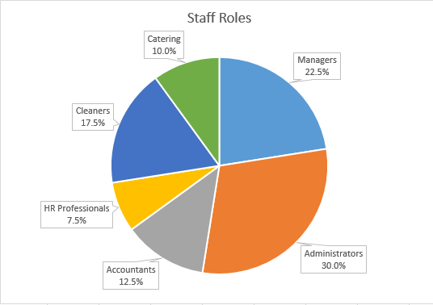

11 NARRATIVE WRITING

What is Narrative?

Often, the word narrative is synonymous with story. A narrative is the story (fiction or non-fiction) told and the order in which it is told. Sometimes, there is a narrator, a character or series of characters, who tell the story. Sometimes, as with most non-fiction, the author himself/herself is the narrator.
You are narrators of your own lives all the time. Something happens in class. You go to lunch; then, you tell the details that are important to you in the order that seems right to you. The story that you tell is a narrative. A reporter who tells a human interest story for the Olympics about an athlete that fought for years to get to the Olympics might emphasize his hardship, the time he had to sleep outside for a week, the eight hours a day that he worked out. The narrative is shaped by details. These details offer clues about the author’s purpose. Clearly, the author who emphasizes the hardships of an Olympic athlete wants to show us that this person overcame adversity to succeed.

Why Write Narrative?

Narrative writing is very important in your day-to-day life. For the rest of your life, you will write texts, e-mails, cover letters, blogs, etc. about your beliefs, your ambitions, information you know, and feelings you have. What could be more important?
Narrative writing in fiction and non-fiction (and even poetry) tells others the stories of our personal experiences and allows us to gain empathy and sympathy about the world around us.

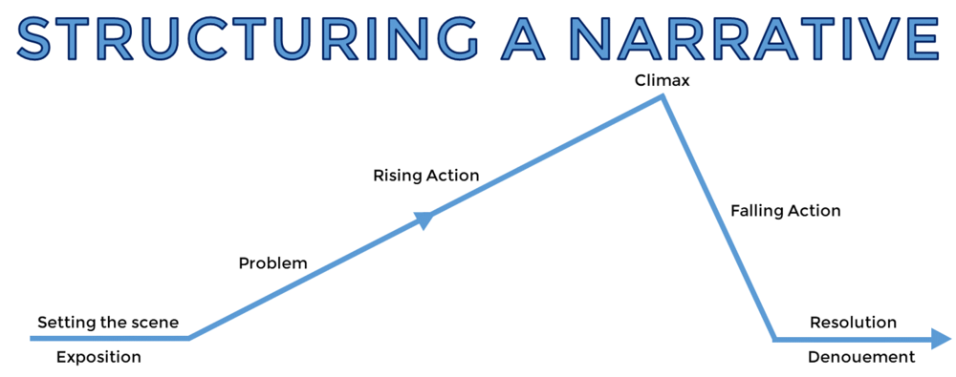

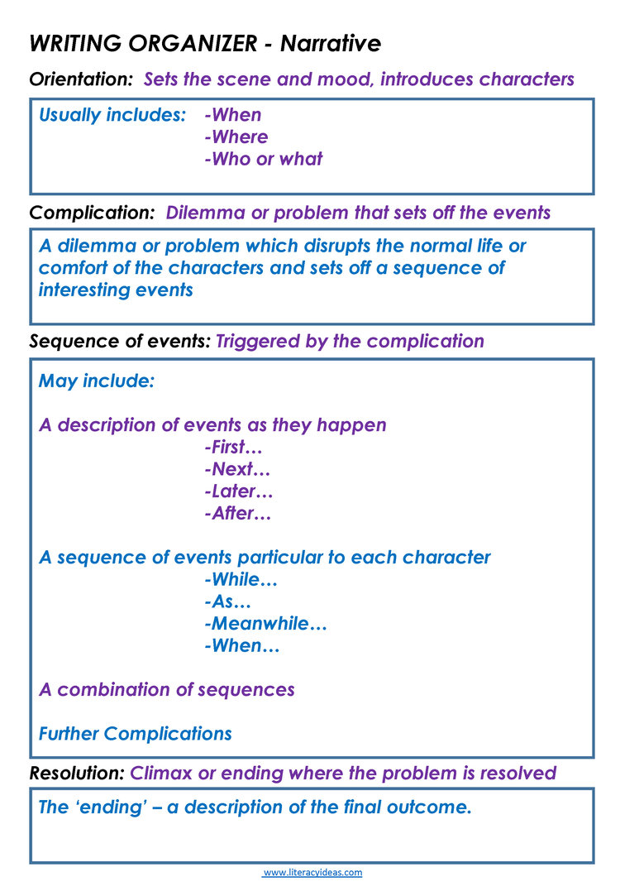

12 CLARIFYING A SEQUENCE: DESCRIBING A PROCESS

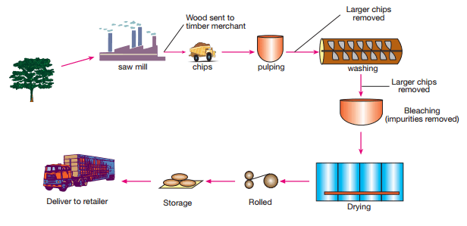
What process is the diagram below explaining? Look carefully at the labels given.
You should have been able to identify that the process describes the production of paper (of course in the official IELTS test, you would also be given a title that states this).
Here’s an excerpt from the task 1 report based in the illustration. What is important about the words in bold, in italics, that are underlined?
After the trees have been cut down and taken to a saw mill, two products remain. There is the timber which is sold, and there is the wood chip. The wood chip is first pulped and then washed

Tip 1: The three rules

When describing a process, remember the following:
- The passive is the most common construction.
- Sequencing words are essential.
- Relative clauses can help avoid repetition.

Saw the trees into timber. Send the timber to the timber merchant.
↓
The trees are sawn into timber, which is then sent to the timber merchant

Tip 2: Accurate sequencing is essential

One of the main tests in writing about a process is your ability to use sequencing words to make full sentences about the process. Here are some useful sequencing words and phrases to describe processes:

first
the first step
then
next
the next step
the third step
after that
before (+ ing)
after (+ ing)
as
while
when
meanwhile
soon afterwards
from then on
the last step
finally
in the process of
in the course of
once (X) has happened, (Y) can happen

Task 1. Use the prompts above the make complete sentences about the paper production process from the following prompts.
e.g. Trees / cut / saw / send / timber merchant – First the trees are cut down and sawn into timber, which is then sent to the timber merchant
- Chips / pulp / wash
- Bleach / impurities removed / larger chips removed
- Bleached pulp / dry / roll
- Store / deliver to retailer
Task 2. Model answer

Here’s a model answer (it would be worth the top score in the official IELTS test) to illustrate. Read the paragraph and note down the useful phrases.
You should spend about 20 minutes on this task.
The diagram below shows the process of publishing a book.
Summarise the information by selecting and reporting the main features, and make comparisons where relevant.
Write at least 150 words.
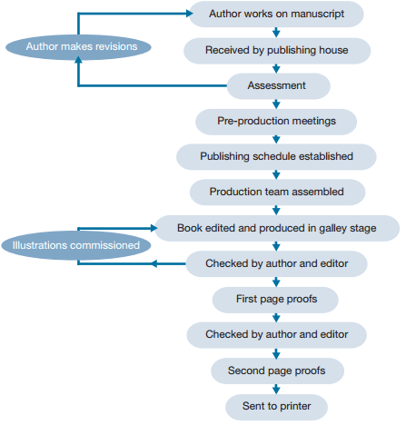
The diagram illustrates the process of developing a manuscript into a published book.
The process begins with the initial writing, which is then sent to a publishing house for assessment. If necessary, the material is then returned for revisions by the writer and this cycle of the process is repeated until it passes the assessment stage.
Following that, the project is discussed in pre-production meetings. Once a schedule has been arranged, a team is brought together for production, and the work is edited and produced in galley stage. This goes to the editor and the writer, following which illustrations are commissioned and the work is checked by the author and the editor. This is then converted into the first page proofs, which are once again checked by both the editor and the writer before moving on to second stage proofs.
The process is concluded when these proofs are sent to the printer.
13 STRUCTURING IDEAS LOGICALLY, CHRONOLOGICALLY

How to structure the content
In general, the structure of an article should follow the following principles:
- “Spiral out”, i.e. start with the core of the topic, then develop ALL its main aspects briefly, then optionally develop some aspects FULLY. In other words, give 2 or 3 successive pictures of the topic, each of them focused on the topic, but with more and more content. This way, the reader can stop reading when s/he has enough information.
- In each of the pictures, follow the chronological order of events when possible. People remember pieces of information better when they are connected. Chronological order is universally understood. For each individual event, explain “who did what when why”, with possible explanations of special challenges, techniques, resources or consequences.
- If the chronological order is not adequate, use the logical order. Make sure that ALL the steps in the logic are stated, in the correct order. To test this, pretend to be ignorant, and challenge each step.
- Each paragraph should convey only one main idea. Connect them together by paragraph leaders (e.g. “Because of this unexpected result, ...”) as much as possible.
- In articles whose topic is especially complex or varied, it may be useful to add a paragraph or section after the introduction which explains the various ways that topic may be described, compared, or considered. such as, “TOPIC may be described many ways including THIS WAY and THAT WAY.”

Examples of Methods of Organization

In the world of business, methods of organization can be used to convey an idea, relay information, assemble a procedure and seal a deal. Methods of organization create order and direct the thoughts of the audience interacting with the information. Whether it is creating a report, sorting data, presenting an idea or organizing facts, choosing a method of organization sets the stage for decision-making.

Chronological Order of Information

Chronological order places each piece of information into a sequence of dates or time frames. This method of organization is helpful when reviewing historical data or explaining why or how a particular result occurred over time. It can also be used to highlight the need for a particular project to occur because of a sequence of events. For example, the need to update, replace or rebuild a technology infrastructure can be presented using chronology to pinpoint purchase dates and previous changes.

Order of Importance

Organizing data by order of importance helps build the strength of an argument or idea. Each new piece of information presented builds on the last piece to result in a logical conclusion. Organizing by importance also works when presenting the most important piece of information first followed by less important information. Using the most important piece of information first can capture the attention of the listener while less important pieces of information support the initial question or idea.
For instance, a presentation designed to sell a medical product might open with the most important fact, such as how many people might be helped by using the product, followed by information supporting the product facts.

Comparison and Contrast

A simple chart of comparison is a method of organization used when a decision must be made among several products, techniques or job candidates. This method of organization identifies the similarities and differences among the products or items being discussed. Comparison and contrast is a method that uses visual tools such as diagrams, charts or lists to convey information.

Geographical Organization Method

Location and geography provide guideposts for sequencing events or organizing business data. Geography can be used to break down sales data by state, region or city, organize a meeting or arrange travel plans. Spatial or location information can help organize the placement of a company's various departments within a building and identify more efficient work arrangements between each group.

Inductive Method of Organization

The inductive method of organization orders information by complexity and places facts before conclusions and recommendations. Facts are presented as an investigation of the parts and pieces of a problem or issue. Conclusions and recommendations are drawn from the investigation of the facts. The inductive organization method is useful when rumors or previously drawn conclusions have caused confusion in the minds of a target audience.

Deductive Organization Method

The deductive organization method begins with a recommendation and follows with information to support that recommendation. Facts, statistics and examples of success or failure can be used to support a recommendation. Deductive organization works well when the target audience is knowledgeable on the topic being presented or when a selection process, such as choosing from a small selection of possibilities, people, projects and location, is undertaken.

Structuring ideas chronologically

Remember:
Chrono = Time
Logic = Order
When information in a passage is organized by the time in which each event occurred, it is organized chronologically. Nonfiction passages that are organized chronologically often contains dates. Fiction passages or narratives are more subtle and are organized chronologically but usually have no dates. A narratives or story is a journey through time, and all of the events are arranged in order of time; therefore, every story has a beginning, middle, and end.

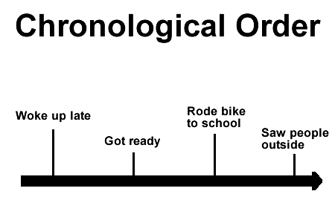
Even if an author uses flashbacks, flash-forwards, or otherwise manipulates the time in his or her text, the events still occur along a timeline. Stories require the passage of time; therefore, all stories are organized chronologically. Sometimes time will stop in a narrative. Certain passages in a story may focus on describing scenary or spaces, and use a descriptive or spatial method of organization. The conflict of a story may be discussed in terms of problem and solution or cause and effect, but the text in a story is still mainly organized chronologically.

Example:
This morning was crazy. My alarm clock was set for PM instead of AM, so I woke up really late. I just threw on some clothes and ran out the door. I rode my bike as fast as I could and thought that I was going to be late for sure, but when I got there everyone was outside and there were firetrucks all lined up in front of school. I guess somebody pulled the fire alarm before class started. It worked out though, because nobody really noticed or minded that I was tardy.

14 WRITING IN THIRD PERSON IN APA STYLE

As the sixth edition of the “Publication Manual of the American Psychological Association” attests, style and tone are important elements of APA papers and publications since they affect how a reader understands information. Point of view is one of the elements that can determine how information is received by a reader

Definitions

Three different points of view exist: first person, second person and third person. First person reflects the writer's voice with pronouns such as “I,” “me,” “we” and “us.” Second person speaks directly to a reader, using pronouns such as “you” and “your.” Third person uses a more general voice that reflects neither the writer nor reader specifically, using words like “students” and “participants” and pronouns such as “he,” “they” and “it.” Good writing typically begins in one point of view and retains that perspective throughout in order to avoid confusion for the reader.

Purpose

Most formal writing, including APA papers, uses the third person point of view. Third person makes ideas sound less subjective since it removes direct reference to the writer. It also creates a more generalized statement. For example, “Researchers first need to determine participants” (written in the third person) conveys a more formal, objective tone than “You first need to determine participants” (second person) and “I first needed to determine participants” (first person). Instructors, institutions and publishers generally require writing in the third person to maintain a more formal tone.

Exceptions

The APA manual explains that third person may not always be appropriate in APA papers. When describing activities you performed in your research or when third person language may confuse the reader, use first person instead. For instance, after a reference to an outside source, if you then write, “The author developed the program,” your reader cannot be certain if “the author” refers to the referenced source or yourself. Using the first person in such cases clarifies your intention.

Grammar

One of the most significant grammatical issues involving the third person point of view is pronoun use. Pronouns must agree in number with the nouns they refer to. For instance, for the plural noun “participants” and the pronoun “they” agree in number while “he” does not. In the third person point of view, writers should use gender-neutral pronouns when appropriate, such as “they.” Some writers consider the use of “he or she” awkward, but the use of “they” can lead to agreement issues. When using “they,” make certain the antecedent noun is also plural.

Tick the correct examples:

 |  | “Even though Smith thinks this way, I think his argument is incorrect.”
√ |  | “Even though Smith thinks this way, others in the field disagree.”
 |  | “If you still disagree nowadays, then you must be ignorant of the facts.”
 |  | “Someone who still disagrees nowadays must be ignorant of the facts.”
 |  | “You might be tempted to agree without all the facts.”
 |  | “One might be tempted to agree without all the facts.”
 |  | “The witness wanted to offer anonymous testimony. They' were afraid of getting hurt if their name was spread.”
 |  | “The witness wanted to offer anonymous testimony. He or she was afraid of getting hurt if his or her name was spread.”
 |  | Bob said to Erika, “I think this is creepy. What do you think?”
 |  | I thought this was creepy, and Bob and Erika thought so, too. What do you think?
 |  | “Tiffany felt awful after the argument with her boyfriend.”
 |  | “Tiffany thought, “I feel awful after that argument with my boyfriend.”
 |  | “I felt awful after the argument with my boyfriend.”
 |  | “Tiffany felt awful, but judging by the expression on Carl's face, she imagined that he felt just as bad if not worse.”
 |  | “Tiffany felt awful. What she didn't know was that Carl felt even worse.”
 |  | “Tiffany watched from the window as Carl walked up to her house and rang the doorbell.”
 |  | “As soon as Tiffany left the room, Carl let out a sigh of relief.”
 |  | “Kevin felt completely enamored of Felicia from the moment he met her. Felicia, on the other hand, had difficulty trusting Kevin.”
 |  | “Felicia hated to admit it, but the roses Kevin left on her doorstep were a pleasant surprise.”
 |  | “The roses left on the doorstep seemed like a nice touch.”

15 HOW TO WRITE AN ABSTRACT

If you need to write an abstract for an academic or scientific paper, don’t panic! Your abstract is simply a short summary of the work or paper that others can use as an overview. An abstract describes what you do in your essay, whether it’s a scientific experiment or a literary analysis paper. It should help your reader understand the paper and help people searching for this paper decide whether it suits their purposes prior to reading. To write an abstract, finish your paper first, then type a summary that identifies the purpose, problem, methods, results, and conclusion of your work. After you get the details down, all that’s left is to format it correctly. Since an abstract is only a summary of the work you’ve already done, it’s easy to accomplish!

1. Getting Your Abstract Started

Write your paper first. Even though an abstract goes at the beginning of the work, it acts as a summary of your entire paper. It will be an overview of everything you write about in your paper. Save writing your abstract for last, after you have already finished your paper.
Review and understand any requirements for writing your abstract. Before you start writing, refer to the guidelines to identify important issues to keep in mind.
- Is there a maximum or minimum length?
- Are there style requirements?
- Are you writing for an instructor or a publication?
Consider your audience. Abstracts are written to help readers find your work. Abstracts also help your readers get at your main argument quickly. Keep the needs of your readers in mind as you write the abstract.
- Will other academics in your field read this abstract?
- Should it be accessible to a lay reader or somebody from another field?
Determine the type of abstract you must write: descriptive, informative or critical.
- Descriptive abstracts explain the purpose, goal, and methods of your research but leave out the results section. These are typically only 100-200 words.
- Informative abstracts are like a condensed version of your paper, giving an overview of everything in your research including the results. It is much longer than a descriptive one
- A critical abstract accomplishes the same goals as the other types of abstract, but will also relate the study or work being discussed to the writer’s own research.

2 Writing Your Abstract

Identify your purpose. The reader wants to know why your research is important, and what the purpose of it is. Start off your descriptive abstract by considering the following questions:
- Why did you decide to do this study or project?
- How did you conduct your research?
- What did you find?
- Why is this research and your findings important?
- Why should someone read your entire essay?
Explain the problem at hand. Abstracts state the “problem” behind your work.
- What problem is your research trying to better understand or solve?
- What is the scope of your study - a general problem, or something specific?
- What is your main claim or argument?
Explain your methods. Now is the part where you give an overview of how you accomplished your study. If you did your own work, include a description of it here. If you reviewed the work of others, it can be briefly explained.
- Discuss your own research including the variables and your approach.
- Describe the evidence you have to support your claim.
- Give an overview of your most important sources.
Describe your results. What is it that you found?
- What answer did you reach from your research or study?
- Was your hypothesis or argument supported?
- What are the general findings?
Give your conclusion. This should finish up your summary and give closure to your abstract. In it, address the following questions in an informative abstract:
- What are the implications of your work?
- Are your results general or very specific?

3 Formatting Your Abstract

Keep it in order. There are specific questions your abstract must provide answers for, but the answers must be kept in order as well. Ideally, it should mimic the overall format of your essay, with a general ‘introduction, ‘body,’ and ‘conclusion.’
Provide helpful information. An abstract should provide a helpful explanation of your paper and your research. Word your abstract so that the reader knows exactly what you’re talking about, and isn’t left hanging with ambiguous references or phrases.
Write it from scratch. Your abstract is a summary, yes, but it should be written completely separate from your paper. Don't copy and paste direct quotes from yourself, and avoid simply paraphrasing your own sentences from elsewhere in your writing. Write your abstract using completely new vocabulary and phrases to keep it interesting and redundancy-free.
Use key phrases and words. If your abstract is to be published in a journal, you want people to be able to find it easily. Try to use 5-10 important words or phrases key to your research in your abstract.
For example, if you’re writing a paper on the cultural differences in perceptions of schizophrenia, be sure to use words like “schizophrenia,” “cross-cultural,” “culture-bound,” “mental illness,” and “societal acceptance.” These might be search terms people use when looking for a paper on your subject.
Use real information. Do not reference ideas or studies that you don’t include in your paper in order to do this. Citing material that you don’t use in your work will mislead readers and ultimately lower your viewership.
Get feedback from someone. Having someone else read your abstract is a great way for you to know whether you’ve summarized your research well. Try to find someone who doesn’t know everything about your project. Ask him or her to read your abstract and then tell you what s/he understood from it. This will let you know whether you’ve adequately communicated your key points in a clear manner.

Task 1. From the list below tick (√) all an abstract is:

a short summary of the work or paper that others can use as an overview
a summary that identifies the purpose, problem, methods, results, and conclusion of your work
a summary of the work you’ve already done
description of what you do in your essay
all of the above
none of the above

Task 2. Put the stages of writing an abstract in chronological order.
- review and understand any requirements for writing your abstract
- explain your methods
- give your conclusion
- identify your purpose
- get feedback from someone
- refer to the guidelines to identify important issues

16 WRITING THE RESEARCH PLAN

Elements of the research plan
1. Title
2. Abstract or summary
3. Background, context or rationale
4. Aims and objectives
5. Hypothesis
6. Literature review
7. Research design and methods
8. Ethical issues
9. Project timetable
10. Deliverables, outputs and outcomes
11. Risk assessment
12. Resources and costs
13. Project evaluation
14. References
15. Appendices

1. Title
The title of your project should be clear and accurate. Try to make it short and memorable, but not at the expense of clarity.
E.g.: An investigation into the use of reading lists as a pedagogical tool to support the development of information skills amongst Foundation Degree students.

2. Abstract or summary
The abstract is an overview of the proposed project/paper. It is one of the first things that your audience will read. It should include the rationale for the work, its main objectives and the methods to be used for achieving these.

3. Background, context or rationale
In this section you should describe why you wish to conduct the project, and why it is relevant, important and timely. This section offers justification for the proposed work; it also demonstrates that you are aware of current developments in your field.

4. Aims and objectives
There should be a clear connection between the research question and the aims and objectives.
The aim of a research project is usually general, while the objectives are more specific or focused questions that will address different aspects of the aim.
In a project management context it is often stated that objectives should be ‘SMART’ i.e. specific, measurable, achievable, relevant (or realistic) and time-bound.

5. Hypothesis
For a more ‘scientific’ or experimental approach, the researcher may choose to generate and test a hypothesis. A hypothesis is a statement of expected behavior.

6. Literature review
Literature may comprise not only scholarly papers; but also national, local or organizational policy documents. You should be familiar with the key issues and theories from your subject area and be able to identify any gaps. You will also have established that your proposed area of research has not in fact already been covered by another researcher.

7. Research design and methods
This section is the heart of your research plan. Its purpose is to describe how you will answer the research question and achieve the project’s aims and objectives.
It should cover the following:
• The overall approach to the research.
• Choice of research method, technique and tools.
• Scope and boundaries.
• Sampling.
• Research data management.

8. Ethical issues
You should describe the main ethical issues (involving either people or animals) likely to arise from your project and indicate how you intend to handle these.

9. Project timetable
Your research project need to be pinned down to a realistic and achievable timescale. You need to work out how long each part of the project is likely to take. It can be helpful to present the project timeline in diagrammatic form, for example using a Gantt chart.

10. Deliverables, outputs and outcomes
Your project deliverables represent its impact on your institution, academia and society. Outputs are the things you will produce as part of your project and are tangible and measurable. Outcomes are the results or consequences of the project.

11. Risk assessment
Every project contains an element of risk. You have four main options in managing risk:

1. Accept the consequences of the risk.
2. Transfer the risk.
3. Avoid the risk.
4. Reduce the risk.
12. Resources and costs
The resources required for a project can range from one researcher with a PC to a multinational research team and a wide range of expensive equipment.

13. Project evaluation
How will you know that your research project has been a success? Define formal success criteria in terms of the research aims and objectives. Methods of evaluation might include feedback from stakeholders, usage statistics, peer review etc.

14. References
Any documents, websites, or other resources referred to in the proposal must be correctly referenced.

15. Appendices
An appendix may be used for supplementary information, for example a copy of a questionnaire or an interview schedule, or for other supporting documentation.

17 HOW TO WRITE BUSINESS LETTERS

Salutation
The salutation is an important part of a letter. The choice of the right salutation depends on whether you know the person you are writing to and how formal your relationship is.

Very formal (for official business letters)

To Whom It May Concern: | Use only when you do not know to whom you must address the letter, for example, when writing to an institution.
Dear Sir/Madam, | Use when writing to a position without having a named contact.
Dear Mr Smith, | Use when you have a named male contact.
Dear Ms Smith, | Use when you have a named female contact; do not use the old-fashioned Mrs.
Dear Dr Smith, | Use when writing to a named doctor.
Dear Prof Smith, | Use when writing to a named professor.
Dear Xu Li, | Type the whole name when you are unsure of the recipient’s gender.

Less formal but still professional (business letters)

Dear colleagues, | Use when writing to a group of people.
Dear Mary, | Use when writing to a named female.
Dear John, | Use when writing to a named male.

Informal (personal letters)
These salutations should be used with people you are close to, as they might offend others.
Hello guys, | Use when writing to a group of people you know very well.
Hi, | Use when writing to one or more people you know very well.
- There should be a comma after the salutation and a colon after “To Whom It May Concern”.
- No full stop is needed after Mr, Ms, and Dr.
- The form Mrs is outdated.
- Avoid the exclamation (!) in salutations.

Starting your letter
There are two ways in which business letters usually start: they make reference to a previous contact, for example, phone conversation, meeting, previous mail correspondence; or they are the first contact with the recipient.

Making reference to previous contact
I am (we are writing) regarding
- your inquiry about …
- our phone conversation …
In reply to your request …
Thank you for contacting us.

Contacting the recipient for the first time
I am (we are) writing to
- inform you that …
- confirm …
- enquire about …
- complain about …
I am contacting you for the following reason.
I recently heard about … and would like to …

Making a request
We would appreciate it if you would …
I would be grateful if you could …
Could you please send me …
Could you possibly tell us …
It would be helpful if you could send us …

Giving good news
We are pleased to announce that …
I am delighted to inform you that …

Giving bad news
We regret to inform you that …
I’m afraid it would not be possible to …
Unfortunately we are unable to …
After careful consideration we have decided …

Ending your letter

Enclosures
Please find enclosed (for letters)
Please find attached (for emails)

Offering future assistance
If you require more information, please let us know.
Please do not hesitate to contact us if you need any further assistance.

Referring to future contact
I am looking forward to hearing from you soon.
We are looking forward to meeting you on 21 January/in Tromsø.
We would appreciate your reply at your earliest convenience.

Closing
The closing salutation must match the opening salutation and the overall tone of the letter. Choose one of the following closing lines depending on the formality of the salutation.

Very formal
Your sincerely,  Sincerely yours,  Respectfully, | Use when you’ve started with Dear Sir/Madam or To Whom It May Concern.
Sincerely, | Use when you’ve started with Dear + name.

Less formal but still professional
Kind regards,  Warm regards,  Regards, | not too formal but businesslike
Best wishes, | even less formal

Informal
Best,  Hugs,  Cheers, | Use with friends and colleagues you feel close to.

Sample #1

Your Company Logo and Contact Information
January 11, 2020
Brian Eno, Chief Engineer
Carolina Chemical Products
3434 Pond View Lane
Durham, NC 27708
Dear Mr Eno,
Enclosed is the final report on our installment of pollution control equipment at Eastern Chemical Company, which we send with Eastern’s Permission. Please call me collect (ext. 1206) or email me at the address below if I can answer any questions.
Sincerely yours,
Nora Cassidy
Technical Services Manager
ncassidy@company.com
Enclosure: Report

Sample #2
Your Company Logo and Contact Information
January 11, 2019
Brian Eno, Chief Engineer
Ecology Systems, Inc.
8458 Obstructed View Lane
Durham, NC 27708
Dear Mr Eno,
Enclosed is the report estimating our power consumption for the year as requested by John Brenan, Vice President, on September 4.
The report is the result of several meetings with Jamie Anson, Manager of Plant Operations, and her staff and an extensive survey of all our employees. The survey was delayed by the transfer of key staff in Building A. We believe, however, that the report will provide the information you need to furnish us with a cost estimate for the installation of your Mark II Energy Saving System.
We would like to thank Billy Budd of ESI for his assistance in preparing the survey. If you need more information, please let me know.
Sincerely yours,
Nora Cassidy
New Projects Office
ncassidy@company.com
Enclosure: Report

18 LINKING WORDS: ADDING, ORGANIZING, AND SUMMARIZING

Adding Information and Examples

for example / for instance
Use these words to give one example of the idea you are talking about. Both of these expressions can go at the beginning or the end of a sentence.
- There are a number of problems in this school. For example, many of the classrooms don’t have audiovisual equipment.
- She has a lot of good ideas for our business – opening an online store, for instance.

Written English: i.e. and e.g
In written English, we can use i.e. to give further explanation or clarification; it means “that is” or “in other words.”
- Our last marketing campaign failed (i.e. we spent $50,000 and didn’t make many sales).
We can use e.g. to give examples; it means “for example”
- I enjoy radical sports (e.g. rock climbing, hang gliding, and windsurfing).
In formal writing, these expressions always appear inside parentheses.

namely / such as
There is a difference between namely and such as.
Namely is followed by ALL of the examples you referred to, but such as gives only one or some of the examples, not all of them.
- A few of the students – namely Brian, Thomas, and Jack – failed the course.
- A few of the students, such as Brian, failed the course.

also / too
Also can go in the middle of a sentence, whereas too is typically used at the end.
- We did a lot of sightseeing on our vacation. We also bought a number of souvenirs.
- We did a lot of sightseeing on our vacation. We bought a number of souvenirs, too.

as well / as well as
As well goes at the end of the sentence (similarly to too).
As well as must be followed by another word.
- She’s not only extremely successful, she’s beautiful as well.
- She’s beautiful as well as being extremely successful.

in addition / moreover / furthermore
These linking words are usually used at the beginning of a sentence to add another idea or further develop the previous point.
- People who exercise regularly have more energy during the day and sleep better at night. In addition, they tend to live longer.
- Construction on the new subway has been delayed for months due to budget shortfalls. Moreover, the workers are threatening to go on strike.
- Our sales are expected to rise 30% in the next year. Furthermore, purchase of new equipment will help cut manufacturing costs and increase profits.
Note: These expressions are more formal English. In informal spoken English, we usually use these expressions instead:
- plus
- what’s more
- besides

Organizing and Ordering Information

Firstly / Secondly
When you are going to make a series of points, you can use firstly and secondly for the first and second points. After that, you can use “The third point,” “The fourth point,” etc. or “in addition.”

Lastly / Finally
For your final point, you can begin the sentence with lastly or finally. These words show your audience that you are almost finished.

the former / the latter
You can use these words to refer back to two examples previously mentioned:
- Our company has two factories: one in Detroit and one in Atlanta. The former is operating at 95% capacity and the latter at 65%.
In this case, “the former” = the factory in Detroit, and “the latter” = the factory in Atlanta.

Summarizing Information

Here are some English phrases you can use to give a summary of the information you have already said or written. In general, these phrases go at the beginning of the sentence and are followed by a comma.
- In short
- In summary
- To summarize
- In conclusion
- In a nutshell (more informal)
Task 1 Choose the correct phrase
- The train was delayed _________ bad weather. (resulting/ on account of/ because/ in view of)
- The event was cancelled _______ the fact that not many tickets were sold. (due to/ so/ because/ therefore)
- I felt stressed ______ I’d been overworked recently. (that’s why/ therefore/ so/ as a result)
- John went to the acupuncturist ______ his bad back. (since/ because of/ consequently/ due to)
- Sonia had a bad stomachache and_______ I recommended seeing the doctor. (as a result/ since/ therefore/ given that)
- _________ the teacher’s good reputation the yoga classes were always crowded. In view of/ Because/ Consequently/ Due to)
- __________ the fact that homeopathy can be very effective for some illnesses it has become increasingly popular. (Therefore/ Since/ In view of/ Given that)
- It’s amazing I can walk _______ an hour ago I couldn’t move. (as a result/ since/ therefore/ given that)
- My headache has disappeared _______ the massage. (due to/ because of/ so/ therefore)
- The company was doing badly and _______ it closed. (consequently/ because of/ seeing that/ on account of)
- ___________ it is your money, you can do what you like with it. (Since/ Resulting/ Consequently/ Therefore)
- My mother wanted to keep her brain active, _________ she took up a hobby.(seeing that/ therefore/ because/ owing to)

19 COMPLEX SUBJECT

1. Knowledge, statement:
to be heard  to be seen  to be watched  to be felt  to be observed  to be noticed | ► | to V
e.g. Bob was heard to laugh heartily.

2. Supposition
to be known  to be thought  to be considered  to be believed  to be expected  to be found  to be trusted  to be supposed  to be imagined  to be assumed | ► | to be
e.g. Philip was known to be a young man without money.
3. Enforcement:
to be made | ► | to V
e.g. Little Bob was made to put on some warm clothes.

4. Message:
to be said  to be reported  to be stated | ► | to V
e.g. He is said to have gone to work to Siberia.
5. Degree of certainty
to seem  to happen  to prove  to be likely  to be unlikely  to be sure  to be certain  to turn out | ► | to V
e.g. They are unlikely to come in time. The work proved to be useful.
Task 1. Paraphrase the following sentences, using complex subject.
E.g.: It is believed that the poem was written by Byron. –
The poem is believed to have been written by Byron.
1. People consider the climate there to be very healthful.
2. It is expected that the performance will be a success.
3. It is said that the book is popular with both old and young.
4. It was supposed that the crops would be rich that year.
5. It was reported that five ships were missed after the battle.
6. It appeared that he was losing patience.
7. It happened that I was present at the opening session.
8. It turned out that my prediction was correct.
9. It seems they know all about it.
10. It seems they have heard all about it.

Task 2. Paraphrase the following sentences, using complex subject.
E.g. We heard that a car stopped outside the door. –
A car was heard to stop outside the door.
1. The graduate students consider the research to be very helpful.
2. It was announced that the Chinese dancers were arriving next week.
3. It is expected that the performance will be a success.
4. It is said that the book is popular with both old and young.
5. It is believed that the poem was written by an unknown soldier.
6. It is supposed that the well-known playwright is working on a new play.
7. It is reported that the flood has caused severe damage to the crops.
8. It was supposed that the crops would be rich that year.
9. It has been found that this mineral water is very good for the liver.
10. Scientists consider that electricity exists throughout space.
11. It is said that the weather in Europe was exceedingly hot last summer.
12. It was reported that five ships were missing after the battle.

Task 3. Paraphrase the following sentences, using the complex subject
Е.g. It appeared that they had lost the way. – They appeared to have lost the way.

1. It seems they know all about it.
2. It seems they have heard all about it.
3. It seemed that the discussion was coming to an end.
4. It seems that you don’t approve of the idea.
5. It seemed that the house had not been lived in for a long time.
6. It appeared that he was losing patience.
7. It appeared that he had not heard what had been said.
8. It happened that I was present at the opening session. 9. It so happened that I overheard their conversation.
10. It turned out that my prediction was correct.
11. It turned out that the language of the article was quite easy.

20 COMPLEX OBJECT

Subject + Predicate + Complex Object (Noun/Pronoun + Infinitive)
The combination of a noun in the common case or a pronoun in the objective case and an infinitive used after the predicate forms a complex object. The relation between the noun (pronoun) and the infinitive is that of subject and predicate.
Key examples:
- I saw the boy raise his hand.
- I heard him call my name.
- I want you to know that it doesn't matter.

The infinitive may be used as a part of a complex object after the following verbs:
1. to hear, to see, to watch, to feel, to let, to make. After these verbs the infinitive has no particle ‘to’.
- I heard him describe his new bedroom suite.
- He makes his children go to bed early.
- I saw him whitewash the fence.

2. to want, to expect, to know, to suppose, to consider, to believe. After these verbs the particle ‘to’ is used before the infinitive.
- He wanted me to help him choose a new computer.
- I consider Bill to be Jack of all trades.
- I expected him to paint the walls green.

Task 1 Fill in the correct form of the Infinitive to make Complex Object.

- Our teacher made us _______ (do) this exercise all over again.
- The teacher advised us _______ (rewrite) the test.
- Please, let me _______ (know) when your sister returns from Paris.
- I find your story _______ (be) very unusual and interesting.
- Nick doesn’t want me _______ (tell) everybody this news.
- I watched the cat _______ (crawl) to the flock of sparrows.
- I would like you _______ (be) very accurate and attentive.

Task 2 Choose the correct ending of the sentences.

1. The doctor wanted the patient …
- to be examined
- to examine
- examined
- being examined
2. Noone expected him … to the party.
- coming
- come
- came
- to come
3. I saw him … round the corner and …
- Turn / disappear
- To turn / to disappear
- Turned / disappeared
- To turn/ disappear
4. I want his article … in November.
- published
- be published
- to be published
- publishing
5. We didn’t want her speech ….
- to be interrupted
- to interrupt
- interrupted
- interrupt

Task 3 Open the brackets and use the Complex Object.

- Do you want (they / stay) at the hotel?
- I would like (the professor / look through) my report.
- We considered (he /be) an honest person.
- I would like (the dress / buy) by Sunday.
- He doesn’t want (they / be late) for dinner.

21 PASSIVE VOICE IN ACADEMIC WRITING

A sentence is considered to be in passive voice when the subject of a sentence is the object being acted on. Active voice, on the other hand, is where the subject is the one doing the acting. In the 20th century, passive voice was a dominant characteristic of scientific writing; however, there has been a discernible shift in consensus in recent years. Most writing guides (such as APA [6th edition, section 3.18]), root for the active voice for clarity and conciseness. According to scholars, the general opinion is that the passive voice makes writing flat and insinuates evasion of responsibility in writing of any form, not just scientific writing.

In fact, some scholars have actually shown that active voice was the preferred form till the beginning of the 20th century when the trend of objectivity became favored. According to Ding (1998), in writing, the world should essentially be represented “in terms of objects, things, and materials.” Passive voice can obscure agents and readers can lose sight of the relevance of a prose that is dominated by things and objects. However, in the art of writing, polarized views often become irrelevant and a balance must be achieved by using the two voices contextually.

After all, human agents are responsible for designing experiments…writing awkward phrases to avoid admitting their responsibility and their presence is an odd way of being objective. - Jane J. Robinson

The APA recommends that verb tenses and voices should be used carefully. Try not to be reluctant to utilize the active voice – particularly in the Discussion section, where it is imperative to express that it is you supposing certain things and having specific assessments. In the Methods section, it is satisfactory to break the dullness of numerous passive voice sentences with the usage of the active voice. A response on Quora (John Geare, 2015) sums up the required balance in a succinct manner:
In academic writing, passive voice is used to describe a process, the results of study, or similar material which is objective in nature. But active voice is used to describe actions.

John Geare provides a specific example for clarity.

My colleagues A, B, [names changed] and I, designed an experiment to test the impact on worker perceptions of well-being when domesticated cats were allowed to freely roam various work environments in which the subjects were normally employed. Three test environments were selected for our experiments: a law office, a laboratory in which experiments were performed using laboratory rats, and an automobile assembly line. One-way mirrored glass panels were installed to allow video cameras to record the activity, and researchers to observe the same and take notes. We secretly inserted observers directly into the work environment. These observers posed as outside contractors, and were uniformed as maintenance and cleaning staff, coffee and water service vendors, and similar supporting personnel. The observers were drawn from the students who were matriculated into the experimental psychology courses from which this study had been developed as an example of such studies generally.

Why use the passive voice in academic writing?
1. Often in academic writing, we don’t want to focus on who is doing an action, but on who is receiving or experiencing the action. The passive voice is thus extremely useful in academic writing because it allows writers to highlight the most important participants or events within sentences by placing them at the beginning of the sentence.
Examples
In the following sentences, the passive construction is preferable because you want readers to focus on the result of an action rather than the person doing the action.
Active | Scientists classify glass as a solid. | The passive sentence focuses on how glass is classified, rather than on who classifies glass.
Passive | Glass is classified as a solid.

Active | Four members of the nursing staff observed the handwashing practices of staff during rostered shifts | The passive sentence focuses on handwashing practices rather than on the four members of staff.
Passive | The handwashing practices of staff were observed by four members of the nursing staff during rostered shifts.
2. In addition, in academic writing sometimes it is obvious, irrelevant or repetitive to state who the ‘doer’ of the sentence is: thus the passive voice is a useful way to construct these types of sentences. It is also a way that the use of informal personal pronouns can be avoided; for example,
1 | One type of work group, the semi-autonomous work group, is discussed in a section later in this chapter. | It is obvious that it is the author who will be doing the discussing.
2 | The group was designed to last for only the lifetime of a particular project. | It is irrelevant to the reader here who did the designing.
3 | The handwashing practices of staff were observed by 4 members of the nursing staff during rostered shifts. Handwashing, or failure to handwash, following patient contact was recorded. Leaving the area without handwashing was considered failure to wash. | The passive is used to avoid repeated reference to the known doer of the action (ie. the observers).
4 | The number of seeds found in ant nests were counted. | The passive allows you to avoid using a personal pronoun (...by us).
3. Sometimes in academic writing it might be expedient to use the passive voice in order to avoid naming the 'doer' of an action so that the message of your text is less inflammatory; for example, read the following excerpt:
In this ideology the argument used to sustain the subjugation of women has largely rested on premises about biological difference - the biological differences between men and women have been used to legitimate hierarchical structures of social inequality. Women, because of their biological function as child bearers, have been traditionally confined to the domestic sphere and excluded from the world ‘out there’. | The identity of the ‘doer’ in this text could be interpreted as society, the dominant social paradigm or males.
Using the active voice in this passage would change the tone of the passage and create quite different message.
Passive voice | Active voice
In this ideology the argument used to sustain the subjugation of women has largely rested on premises about biological difference - the biological differences between men and women have been used to legitimate hierarchical structures of social inequality. Women, because of their biological function as child bearers, have been traditionally confined to the domestic sphere and excluded from the world ‘out there’. | In this ideology the argument used to sustain the subjugation of women has largely rested on premises about biological difference - society has used the biological differences between men and women to legitimate hierarchical structures of social inequality. Society has traditionally confined women, because of their biological function as child bearers, to the domestic sphere and excluded them from the world ‘out there’.
The text in the active voice focuses on the ‘doers’, that is society, rather than on women, the people acted on by the actions of others. The tone of the text is also much more political and accusatory: ‘Society has ... confined women... and excluded them’, rather than descriptive and explanatory.
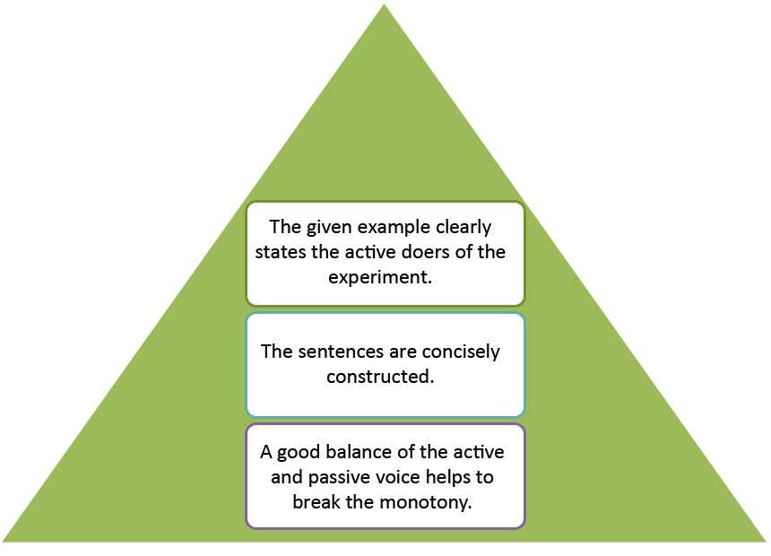
Task 1. Rewrite these passive voice sentences with direct and indirect objects in a more natural way.
1. A postcard has been sent to Jill. ____________________________________
2. A new chance will be given to me. __________________________________
3. Bad news was told her. ____________________________________________
4. Millions of books are bought for students each year. _____________________
5. His place will be offered to Alan. ____________________________________
6. This information must be sent to Ann. ________________________________
7. Such a bracelet had been given to my mum. ____________________________
8. The garden was sold to the Simpsons. ________________________________
9. A letter has been shown to his parents. _______________________________
10.Higher wages will be promised to workers. ___________________________
11.This book is lent to readers very often. ________________________________
12.Wrong meals have been served to us. _________________________________
13. A present has been bought for our teacher. ____________________________
14.The key was left for you at the reception desk. __________________________

Task 2. Rewrite sentences from the active to passive voice.

1. Ford offered Bill a job.
Bill ______________________________________________________________ .
A job ____________________________________________________________ .
2. My partner will send you the fax.
You_____________________________________________________________ .
The fax__________________________________________________________ .
3. My parents give me pocket money.
I ________________________________________________________________ .
Pocket money _____________________________________________________ .
4. The mayor promised new flats to people.
People ___________________________________________________________ .
New flats_________________________________________________________ .
5. The teacher will show slides to students.
Students __________________________________________________________
Slides ____________________________________________________________ .
6. The bank will lend them money.
They _____________________________________________________________ .
Money ___________________________________________________________ .
7. The manager gave them a discount.
They _____________________________________________________________ .
A discount ________________________________________________________ .
8. Your secretary has provided me the information.
I ________________________________________________________________ .
The information ____________________________________________________ .
9. Messi is passing the ball to Neymar.
Neymar __________________________________________________________.
The ball _________________________________________________________ .
10. The delivery boy hands the parcels over to the customer.
The customer ______________________________________________________ .
The parcels ________________________________________________________ .

22 SEQUENCE OF TENSES

The verb in the subordinate clause changes its tense in accordance with the tense of the verb in the main clause. This principle chiefly applies to adverb clauses of purpose and noun clauses.
Here are the basic rules:
1. A past tense in the principal clause is usually followed by a past tense in the subordinate clause.
- She said that she would come.
- I realized that I had made a mistake.
- I worked hard that I might succeed.
- I found out that he was guilty.
There are a few exceptions to this rule.
A past tense in the principal clause may be followed by a present tense in the subordinate clause when the subordinate clause expresses a universal truth.
- The teacher said that honesty is the best policy. (NOT The teacher said that honesty was the best policy.)
- Galileo maintained that the earth moves around the sun.
When the subordinate clause is introduced by than, it may be in any tense even if the verb in the main clause is in the past tense.
- He loved me more than he loves his own children.
- He loved me more than he loved his own children.
- He loved me more than he will love his own children.
A present or future tense in the principal clause may be followed by any tense in the subordinate clause.
- He says that she was at the club.
- He says that she is at the club.
- He says that she will be at the club.
- He will say that she was at the club.
- He will say that she is at the club.
- He will say that she will be at the club.
Notes
When the verb in the main clause is in the future tense, we often use a present tense in the subordinate clause to refer to future time.
- I will call you when he comes. (NOT I will call you when he will come.)

Task 1 Choose the most appropriate answer.

1. I knew that she ________ Madrid before, so I asked her to recommend a good hotel.
- has visited
- has been visiting
- visited
- had visited

2. She promised to help me if I _________ the answer myself.
- Haven’t found
- Didn’t find
- Won’t find
- Wouldn’t find

3. He said that they ________ each other for many years.
- know
- have known
- knew
- had known

4. I saw that she _________ to hold back her tears.
- tries
- is trying
- has been trying
- was trying

5. He knew that she ________ as her eyes were red.
- is crying
- has been crying
- was crying
- had been crying

6. I asked her whether she _______ there with me, but she said no.
- goes
- is going
- will go
- would go

7. She said that the robber ______ her when she was opening the door to her apartment.
- attacked
- has attacked
- was attacking
- had attacked

8. I wanted to see her but I didn't know if she ______ in town.
- is
- was
- were
- had been

9. He told me that he would visit them when he _______ from Spain.
- has returned
- returned
- will return
- would return

10. My younger daughter learned in class yesterday that the Earth ______ around the Sun.
- revolves
- is revolving
- revolved
- was revolving

23 INFINITIVE CLAUSES

In English grammar, an infinitive clause is a subordinate clause whose verb is in the infinitive form. Also known as an infinitival clause or a to-infinitive clause
The infinitive clause is called a clause because it may contain such clausal elements as a subject, object, complement, or modifier. Unlike most other subordinate clauses in English, infinitive clauses are not introduced by a subordinating conjunction.
Verbs that can be followed by infinitive clauses (as objects) include: agree, begin, decide, hope, intend, like, plan, and propose.

Examples and Observations

- “I’m sorry but there’s a handsome man in my spoon. You’ll have to come back later.”
(Tom Tucker, “The Kiss Seen Round the World.” Family Guy, 2001)
- Jane was firm in her desire to live life on her own terms.
- Desperate to prove his innocence, Jamal tells the story of his life in the slums of Mumbai.
- “If you want to make God laugh, tell him about your plans.”(Yiddish proverb)
- “We merely want​ to live in peace with all the world, to trade with them, to commune with them, to learn from their culture as they may learn from ours, so that the products of our toil may be used for our schools and our roads and our churches and not for guns and planes and tanks and ships of war.”
(President Dwight Eisenhower, quoted in Time magazine, 1955)

Infinitive Clauses as Subjects and Objects

A subordinate clause with an infinitive often acts as the subject or object of the main clause. In the following examples, the whole infinitive clause [in bold] is understood as the subject of is human, is decadent or was unnecessary.
- To err is human.
- To drink Martinis before noon is decadent.
- For Mervyn to redirect Maggie’s mail was unnecessary.
And in the following examples, the whole infinitive clause [again in bold] is understood as the direct object of hates, loves and expected.
- Jim hates to wash his car.
- Rosie loves to plan parties.
- Phil expected Martha to stay at home all day.
In case this is not obvious at first, you can test this by answering questions such as What does Jim hate? (answer: to wash his car), or What did Phil expect? (answer: Martha to stay at home all day).

Perfect Infinitives

To express time preceding that of the main verb, the infinitive takes a perfect form: ‘to’ + have + past participle.
- The parents were lucky to have found this specialist for their sick child.
The perfect infinitive can be used with progressive aspect to emphasize duration. This construction consists of ‘to’ + have + been + V-ing.
- He was too scared of the police to have been telling lies all the time.

Passive Infinitives
An infinitive that is derived from a passive finite verb clause will itself be passive:
a. I expect that all the calamari will be eaten before 7:00. (passive verb)
b. I expect all the calamari to be eaten before 7:00. (passive infinitive)
You can verify that to be eaten is a passive infinitive in (b) because it contains the passive marker [BE + (-en)]: be eaten. Remember that eaten is a transitive verb; in its active form, it will have a subject (an indefinite pronoun like someone or they) and a direct object (all the calamari).

Task 1. Put the words in order to build sentences with infinitive clauses

- I to want us you with come ________________________________________
- to He phone like Betty would him.___________________________________
3. be to Jim I angry. want don't________________________________________
4. someone to to listen She like would her._______________________________
5. me two call Wendy to I o'clock am expecting at_________________________
6. expect Mrs us dinner to Smith We to invite_____________________________
7. a lend you wants He to me book.______________________________________
8. He said boys play wanted to he the football._____________________________
9. needs her. someone help She to_______________________________________
10. people rude be hate to I ___________________________________________

Список литературы

- Sheldon Smith ( 2019, September 08) Understanding Lectures Retrieved from https://www.eapfoundation.com/listening/notetaking

CFI Education Inc. (2019). What is Corporate Structure? Retrieved from https://corporatefinanceinstitute.com/resources/knowledge/finance/corporate-structure/
- Central Scientific Library of Ministry of Education and Science of the Republic of Kazakhstan (Kazakhstan) (2019) Retrieved from http://www.library.kz/
- Virginia Kearney (2019, April 10) How to Write a Summary of an Article Retrieved from https://owlcation.com/academia/How-to-Write-a-Summary
- The Project Risk Coach. (2019). 10 Ways to Improve Your Project Presentations. Retrieved from https://projectriskcoach.com/10-ways-to-improve-your-project-presentations/

Sheldon Smith. (2018). Language for presentations. Retrieved from https://www.eapfoundation.com/speaking/presentations/language/

Task 1 Describing Processes (2019) Retrieved from https://www.englishpracticeonline.com/task-1-describing-processes/
- Alex Burke. (2019, March 07) Examples of Methods of Organization. Small Business - Chron.com, Retrieved from http://smallbusiness.chron.com/examples-methods-organization-18982.html
- Kristie Sweet (2017, March 07) Writing in Third Person in APA Style Retrieved from https://penandthepad.com/writing-third-person-apa-style-2056.html
- Megan Morgan. (2019). How to Write an Abstract. Retrieved from https://www.wikihow.com/Write-an-Abstract
- O’Leary, Z. (2010) The essential guide to doing your research project. 2nd ed. London: Sage. p.67
- Marina Pantcheva How to Write Business Letters Retrieved from https://site.uit.no/english/writing-style/letters/
- John Geare (2015, August 29) Why shouldn’t we use a passive voice in academic writing? Retrieved from https://www.quora.com/Why-shouldnt-we-use-a-passive-voice-in-academic-writing
- Richard Nordquist (2019, October 18) Definition and Examples of Infinitive Verbs, Retrieved from https://www.thoughtco.com/infinitive-verbs-term-1691166
- University of Leicester (2019) Poster presentations Retreived from
https://www2.le.ac.uk/offices/ld/resources/presentations/designing-poster/poster

